Khangai Herds 7- Medicinal Treatment
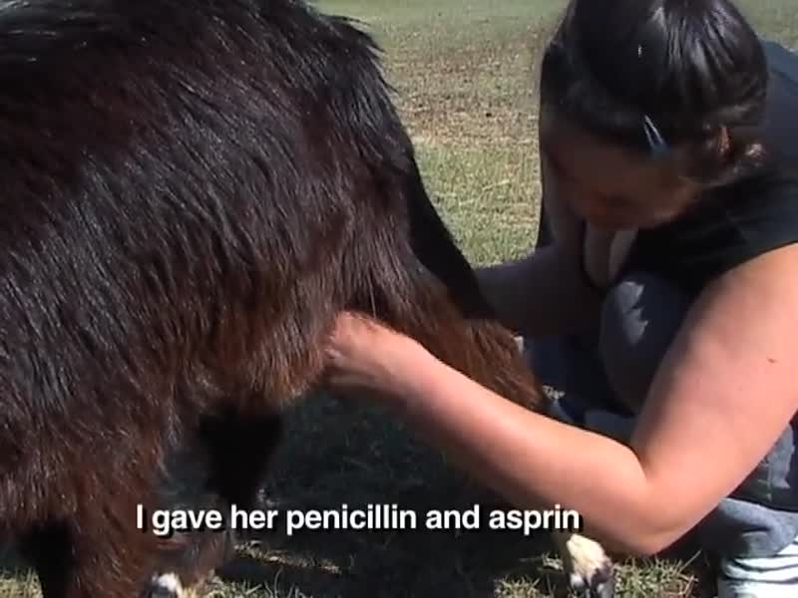

identifier
96c89dfd-22c6-45d5-ad31-2625b7ef971f

creator
Fijn, Natasha

type
Moving Image

coverage
Mongolia

description
This segment of Khangai Herds shows how the Mongolian herder, Lhagva, treats her herd animals using medicinal herbs. This segment also shows the ritual and ceremony surrounding an important event in the herding calendar: the castration of the lambs and kids.

publisher

source
<https://vimeo.com/13511316>

rights
<https://creativecommons.org/licenses/by-nc-nd/3.0/>

subject
Living with Herds
animal care
co-domestic
domestication
ethnography
goat
human-animal
khangai herds
lamb and kids
magic medicine
medicinal herbs
observational film
pastoralism
visual

date
2010-07-21

language
Mongolian

format
video/mp4

contributor

original filename
Khangai Herds 7- Medicinal Treatment.mp4

remote embed url
https://player.vimeo.com/video/13511316

relation

extent
35.6MiB
419.398333

